Parking for March Across the River: Stop PennEast Pipeline
Event: 8/22/15 for New Jersey Side – Includes March Route and Timeline
Look for GREEN STARS for parking areas/(Ask Attendant at Veteran’s Park for Handicap Parking Areas)…..
and Alpha for eatery designations.
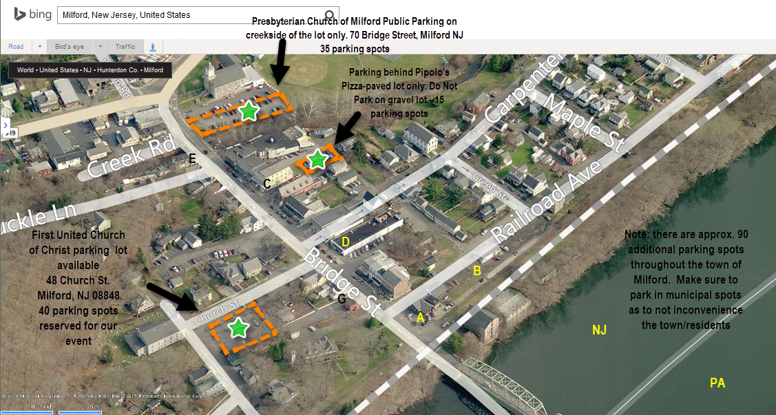
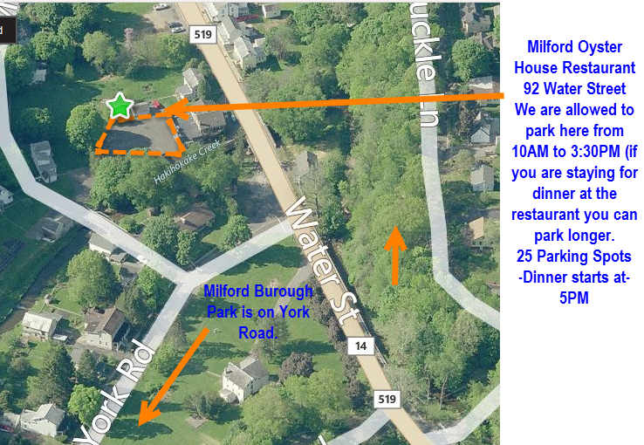
Diagram of entire “March Across the River: Stop PennEast Pipeline” Route: One Mile in length
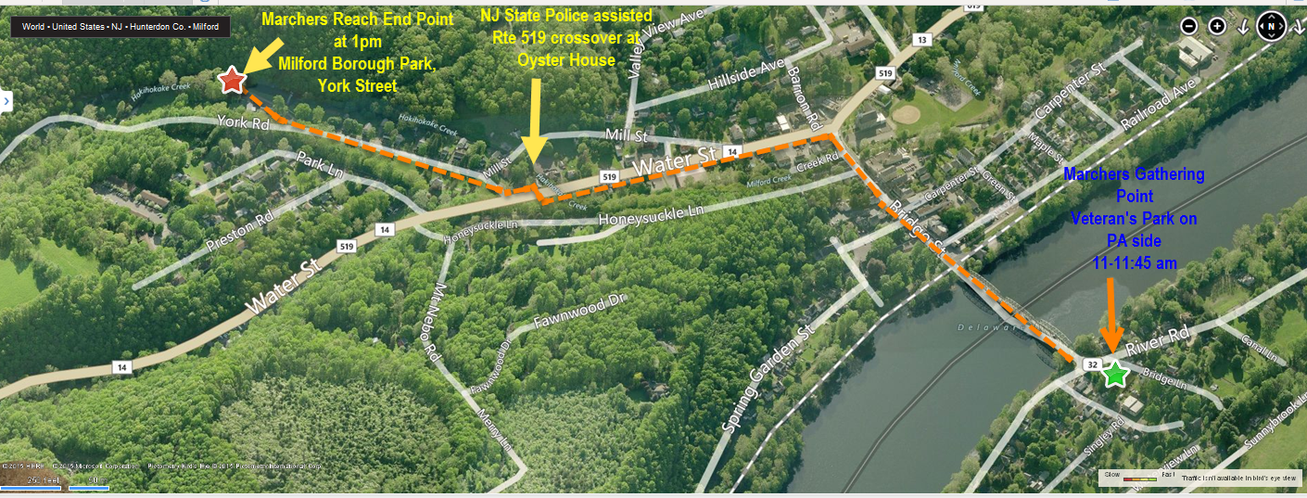
TIMELINE
March Across the River: Stop PennEast Pipeline - Event Aug. 22, 2015 SAT. March takes place solely on the SIDEWALKs
Collage Activity: There will be a Photo Table for Everyone to Express their Opposition to Different Orgs. e.g Ferc/Drbc/Legislators etc..
There will also be Tables for Us to sign Pledges to Stop PennEast Pipeline and Drbc, etc….
11AM - 11:45AM | Gathering for March on Pennsylvania side at Veterans Park - see screenshot below: Native American Drumming
11:45 AM to Noon | Lenni Lenape - "Prayer to the River"
Noon-12:20 | People begin marching over PA Route 32 (with traffic assistance) toward the bridge -- Native American Drumming
12:20 -12:40 | Marchers Stop on Bridge to hold signs for Aerial Shot from plane …  Marchers begin to March again moving toward and through the town of Milford, NJ side of the bridge
12:40 | Marchers arrive at crosswalk at Rte. 519 by The Oyster House continuing down York Rd.- State Police assistance for road crossing
1PM | Marchers reach their destination at the Milford Borough Park on York Road.
1PM to 2:00 PM | 6 Designated Speakers (3-5 minutes each) , Children Art Activities , Graffiti Artist- usage of large plywood to do graffiti art on.
2:30 PM - 3:15 Drum Circle | Drum Circle
3:30 | Closing ceremony by Lenni Lenape

Milford Eateries/ Restaurants- see Alpha in corresponding MAP above
A) Milford Station Bakery B) Ma Dees Chat Shop (Open 7a.m.-1 p.m.)
Sat . 6am-3pm

C) Pipolos Pizza D) Milford Market (subs, sandwiches)
Panda House – Chinese Food

E) Ship Inn Brew Pub F)Oyster House (dinner only-5PM) See Parking Map
G) Maria’s Perogies –Closed during Event, opens in evening around 5PM.

